ZECPATH AI SYSTEM ARCHITECTURE

AI System architecture diagram, Data Flow Diagram
& I/O specification for each AI Engine.

Project Prepared By ALINA ANSARI
AI Developer Intern

AI SYSTEM ARCHITECTURE

Objective:
To design the full AI ecosystem of Zecpath and define how AI systems interact with the backend and frontend, follow these structured steps aligned with the given tasks and deliverables:

Detailed Tasks:
1. Design an AI microservices‑based architecture:
- Break the AI system into five logical services:
- ATS AI Service: manages applicant tracking.
- Screening AI Service: filters resumes.
- Interview Intelligence Service: analyzes interviews.
- Behavior Analysis Service: assesses candidate behavior.
- Decision & Scoring Service: evaluates and scores candidates.
- Use containerization (Docker) for each service to ensure isolation and scalability.

2. Define data flow for each service:
- Receives from backend: JSON data like resumes, interview recordings, or candidate profiles.
- Processes internally: apply AI models (NLP, ML) for analysis.
- Returns to backend: processed results like scores, insights, or recommendations.

3. Design AI service communication:
- REST APIs: use for synchronous requests (e.g., real‑time scoring).
- Webhooks: employ for asynchronous notifications (e.g., processing completion).
- Queues: implement message queues (RabbitMQ/Kafka) for decoupling services and handling async tasks like resume uploads.

4. Define synchronous vs asynchronous flows:
- Synchronous: immediate API calls for interview processing that needs instant feedback.
- Asynchronous: queue‑based processing for resume uploads or batch analysis to improve performance.

5. Considerations:
- Scalability: deploy services on Kubernetes for auto‑scaling.
- Isolation: separate containers for each microservice.
- Model versioning: use MLflow or DVC to manage AI model versions.

Deliverables:
- Create an AI system architecture diagram showing microservices and interactions.
- Draw a data flow diagram illustrating Backend ↔ AI services ↔ Storage interactions.
- Document input/output specifications for each AI engine (JSON schemas, API contracts.

- AI System Architecture Overview

The architecture follows a decoupled, event-driven pattern. The backend acts as the orchestrator, while AI services operate as independent workers scaled via Docker/Kubernetes.

Architectural Principles:

- Isolation: Each service uses its own optimized hardware (e.g., Screening on CPU, Behavior Analysis on GPU).
- Asynchronous Processing: Long-running tasks (video analysis) use message queues to prevent timeouts.
- Model Versioning: Each service exposes a versioned API (e.g., /v1/screen) to allow for A/B testing of new LLM prompts or models.

- Microservice Definitions & Data Specs

Service | Primary Responsibility | Input (From Backend) | output(To Backend)
ATS AI | Parsing & Entity Extraction | Raw PDF/Docx, Job Description | Structured JSON (Skills, Exp, Education)
Screening AI | Shortlisting & Matching | Parsed Resume, JD, Custom Criteria | Match Score (0-100), Gap Analysis
Interview Zecpath | Speech-to-Text & Technical Grading | Audio/Video Stream, Answer Key | Transcript, Accuracy Score, Tech Grade
Behaviour AI | Soft Skills & Sentiment | Video Frames, Audio Tone | Emotional Pulse,  Confidence Level, Soft Skills
Decision AI | Final Aggregation & Ranking | Scores from all other services | Final Recommendation (Hire/Reject/Hold)

- Communication Strategy: Sync vs. Async

To ensure a smooth UI, we categorize Al tasks by their "wait time":

Synchronous (REST API)

- Use Case: Small, instant tasks (e.g., parsing a single resume, generating a single interview question).

- Flow: Frontend \(\rightarrow \) Backend \(\rightarrow \) AI Service \(\rightarrow \) Response.

Asynchronous (Message Queues - RabbitMQ/Kafka)

Use Case: Heavy processing (e.g., analyzing a 30-minute interview video).
Flow:
1.Backend uploads file to S3 and pushes a message to the Queue.
2.AI Service picks up the task, processes it in the background.
3.AI Service sends a Webhook or updates a Status Flag in the DB when finished.
4.Frontend polls or receives a WebSocket notification.

- Data Flow Diagram (Backend ↔ AI ↔ Storage)

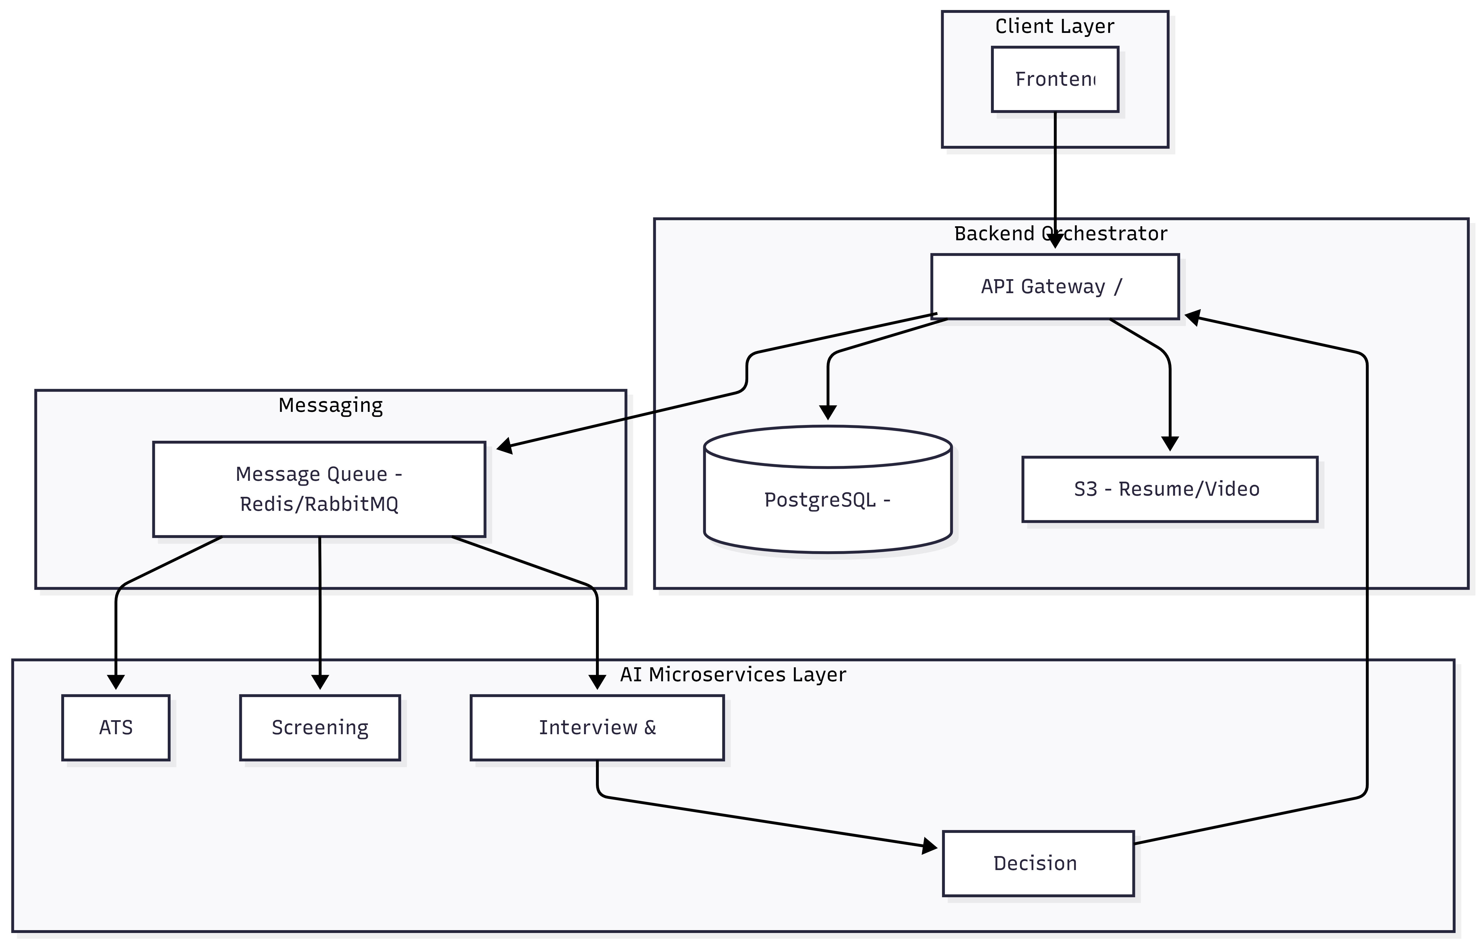

AI SYSTEM ARCHITECTURE DIAGRAM

ATS AI service

Screening AI Service

Database / storage
Interview AI service

Backend (API Server)
Frontend
(web/App)

Behaviour Analysis service

Decision and Scoring service

Input/Output Specification for each AI engine

Resume Parser AI
Input: Candidate's resume or CV
Output: Extracts all important details like name, education, skills, and experience

ATS Scoring AI
Input: Candidate details and job description
Output: Gives a score showing how well the candidate fits the job requirements.

Voice Screening AI
Input: Candidate's voice responses to screening questions
Output: Communication score and feedback on clarity and fluency

HR Interview AI
Input: Candidate answers during HR interview (video/audio)
Output: Evaluates behavior, attitude, and cultural fit

Technical Interview AI
Input: Candidate's answers to technical questions or coding tasks
Output: Technical skill score and assessment report

Machine Test AI
Input: Candidate's practical or real-world skill tests
Output: Skill score and pass/fail evaluation

Behavior AΙ
Input: Candidate's facial expressions, gestures, and voice tone during interviews
Output: Confidence level, stress analysis, and overall behavior evaluation

Decision AI
Input: Scores from all previous Al engines
Output: Final selection of the best candidates

Salary Negotiation AI
Input: Candidate profile, market salary data, and company policies
Output: Suggests a fair salary for the candidate

Offer Automation AI
Input: Selected candidate and approved salary
Output: Automatically generates and sends the offer letter

Compliance Al
Input: Candidate personal data and consent forms
Output: Ensures all legal, privacy, and data consent rules are followed

